Interactive Mapping Application for Environmental Monitoring and Forecasting

Contents
1. Introduction 5
2. Dataset Collection 5
2.1 Primary Air Quality Dataset 5
2.2 Secondary Geographic Dataset 6
2.3 Dataset Summary 7
3. Dataset Overview 8
3.1 Dataset Structure 8
3.2 Dataset Attributes 8
3.3 Pollutants Available in the Dataset 9
3.4 Initial Data Characteristics 9
4. Exploratory Data Analysis (EDA) 10
4.1 Distribution of Pollutant Values 10
4.2 Pollutant Frequency Analysis 11
4.3 Average Pollution Over Time 12
4.4 Pollutant Distribution Comparison 12
4.5 Top Monitoring Stations Analysis 13
4.6 Summary of EDA Findings 14

List of Figures

Figure 1: Initial Dataset Preview and Structure Analysis of Air Quality Data Using Pandas 6
Figure 2: Acquisition of the Secondary Air Quality Dataset Using Kaggle API 7
Figure 3: Preview of the UK DEFRA Air Quality Dataset After Loading into the Analysis Environment. 7
Figure 4: Distribution of Pollutant Concentration Values in the Air Quality Dataset 10
Figure 5: Frequency Distribution of Pollutants in the Air Quality Dataset 11
Figure 6: Temporal Trend of Average Pollutant Concentrations 12
Figure 7: Comparative Distribution of Pollutant Concentrations by Pollutant Type 13
Figure 8: Top Air Quality Monitoring Stations by Number of Recorded Observations 14

List of Tables

Table 1: summarises the datasets used in this research. 7
Table 2: Description of Attributes in the Primary Air Quality Dataset 8

1. Introduction
Air pollution is a major environmental threat to ecological sustainability and human health across the globe. Pollutants such as Nitrogen Dioxide (NO₂), Ozone (O₃), Particulate Matter (PM10) and Sulphur Dioxide (SO₂) are known to cause respiratory illnesses, heart and blood vessel disease, and damage to the environment. Therefore, monitoring and analysis of air quality data is crucial to understand air pollution patterns and help guide good environmental management practices. DEFRA maintains a comprehensive air quality monitoring network in the UK. These monitoring stations are gathering pollutant data continuously in various regions, generating huge amounts of environmental data. This data can be used to gain valuable insights into the trend of pollution, seasonal changes, and geographical differences in air quality.
This project is to create an air quality prediction and hotspot detection system based on the concentration of Nitrogen Dioxide (NO₂). The process of predictive modelling requires a thorough exploration of the data structure and characteristics, which is achieved by the process of exploratory data analysis (EDA). Hence, this Technical Progress Report is an account of the process of dataset collection, an overview of the dataset and an exploratory analysis of the air quality data. The results achieved in this step will be used to guide the following pre-processing, feature engineering, machine learning model building and hotspot detection steps.

2. Dataset Collection

2.1 Primary Air Quality Dataset
The main data used in this study were sourced from the DEFRA UK-AIR (Department for Environment, Food and Rural Affairs – United Kingdom Air Information Resource) platform. The data includes air quality data from monitoring sites spread throughout the United Kingdom. Data contains information about several pollutants, monitoring sites, time and site properties. Ten main attributes can be found in the dataset: StartTime, EndTime, Status, Unit, Value, PollutantName, SiteName, SiteType, Region and Country. A record is a data sample taken from a monitoring station at a particular monitoring time and for a given pollutant. The pollutants are: Nitrogen Dioxide (NO₂), Ozone (O₃), Particulate Matter (PM10), Sulphur Dioxide (SO₂). Nitrogen Dioxide (NO₂) has been chosen as the main pollutant of interest because it is a major air quality pollutant and a public health issue. NO₂ levels are typically high in traffic, industrial and urban pollution areas. So, the key objective of this research is the prediction of NO₂ contents is the main objective.
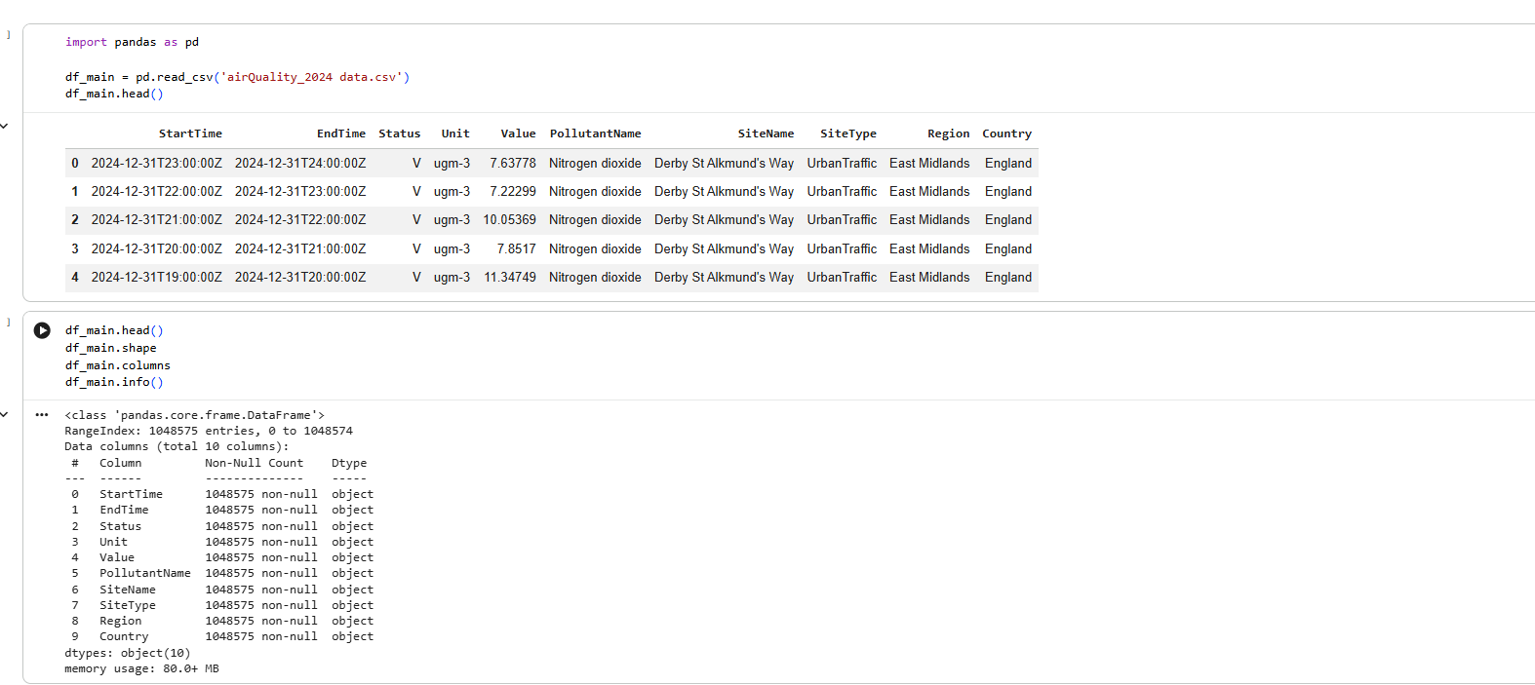
Figure 1: Initial Dataset Preview and Structure Analysis of Air Quality Data Using Pandas
Observation
The data has 10 attributes and 1,048,575 records. The first look at the data revealed that pollutant data are available from several monitoring stations in various parts of England.

2.2 Secondary Geographic Dataset
Kaggle was used to collect a secondary dataset for use in the spatial analysis part of the project. The data used were the UK DEFRA AURN air quality dataset (2015-2023), which included air quality and geographic data for monitoring stations. Key characteristics of this dataset are monitoring station name, latitude, longitude, site type, and pollutant data. The data set includes several environmental variables, but it was necessary only for geographic attributes to be used in this study. The main use of this data set was to get the latitude and longitude of monitoring stations. These geographic coordinates are fundamental for spatial clustering, hotspot detection and mapping visualisation. These were subsequently linked to the main DEFRA data to enable space-related analysis of pollution.
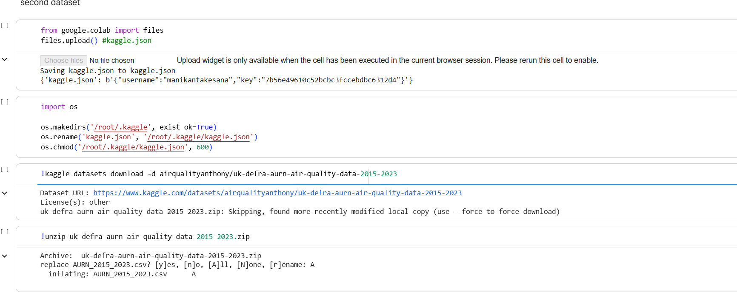
Figure 2: Acquisition of the Secondary Air Quality Dataset Using Kaggle API
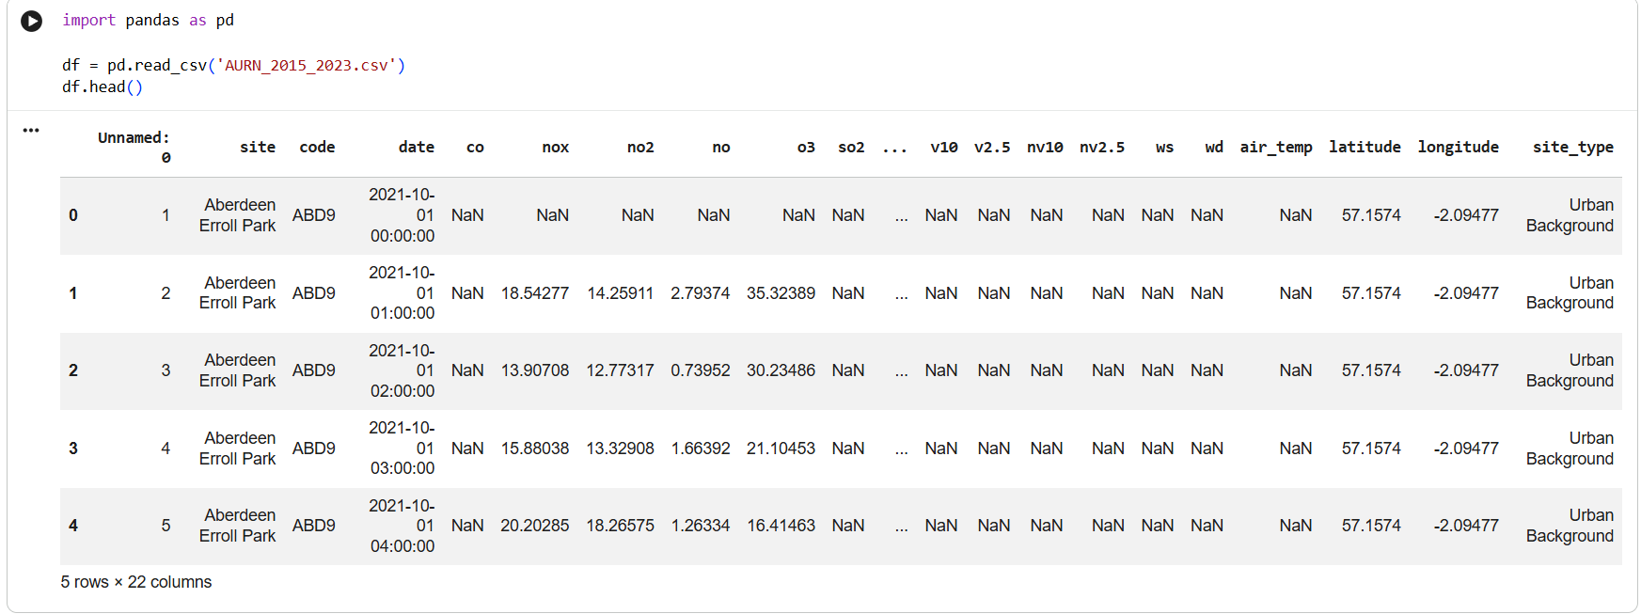
Figure 3: Preview of the UK DEFRA Air Quality Dataset After Loading into the Analysis Environment.
Observation
Geographical coordinates of air quality monitoring sites in the United Kingdom. These coordinates will be available for clustering and hotspot identification in subsequent steps of the project.

2.3 Dataset Summary
Table 1: summarises the datasets used in this research.
Dataset | Source | Purpose
Air Quality Dataset (airQuality_2024_data.csv) | DEFRA UK-AIR | Exploratory analysis, preprocessing, feature engineering, and machine learning model development
AURN Dataset (AURN_2015_2023.csv) | Kaggle | Geographic coordinate extraction, spatial clustering, hotspot detection, and map visualisation
These two datasets together not only provide geographic information but also environmental information, which allows a comprehensive analysis of the air pollution patterns and the development of prediction and hotspot detection models.

3. Dataset Overview

3.1 Dataset Structure
Following data collection, an exploratory analysis of the main air quality data was completed to gain an understanding of the structure and content of the data. The data comprises 10 attributes for 1048,575 records of pollutant measurements from monitoring stations within different regions of the United Kingdom. Individual records represent a measure of a specific pollutant at a specific time and place. The data contains the temporal data, pollutant data, monitoring station data and geographical classification. There are many records, making the data appropriate for environmental analysis and machine learning applications.
Observation
The dataset contains a substantial volume of observations, providing sufficient data for identifying pollution patterns and supporting future predictive modelling tasks.

3.2 Dataset Attributes
The primary dataset consists of ten attributes, each providing specific information about pollutant measurements and monitoring stations.
Table 2: Description of Attributes in the Primary Air Quality Dataset
Attribute | Description
StartTime | Start time of pollutant measurement.
EndTime | End time of pollutant measurement
Status | Validation status of measurement
Unit | Measurement unit of pollutant concentration
Value | Measured pollutant concentration
PollutantName | Name of the pollutant
SiteName | Monitoring station name
SiteType | Type of monitoring station
Region | Geographic region within the UK
Country | Country where the station is located
These attributes provide both environmental and contextual information required for analysing pollution behaviour across different locations and periods.
Observation
The dataset contains a combination of temporal, environmental, and location-based attributes, enabling comprehensive analysis of air quality conditions.

3.3 Pollutants Available in the Dataset
The data set includes measurements for a number of key air pollutants, which are measured at sites by the DEFRA UK-AIR network. The pollutants are used as indicators of air quality and environmental health.
The main pollutants available include:
- Nitrogen Dioxide (NO₂)
- Particulate Matter (PM10)
- Ozone (O₃)
- Sulphur Dioxide (SO₂)
For this research, Nitrogen Dioxide (NO₂) is chosen as the target pollutant, as it is one of the pollutants which poses major threats to human health and has a close correlation with traffic-related pollutants and urban air quality problems.
Observation
The dataset contains multiple pollutant categories, enabling comparative analysis of pollution levels across different pollutant types.

3.4 Initial Data Characteristics
The dataset was initially inspected and found to include pollutant data measurements from many monitoring stations in various parts of England. The measurements are carried out hourly, thus offering detailed temporal information for environmental analysis. The data is a combination of categorical and numerical. PollutantName, SiteName, Region and SiteType are categorical variables, and pollutant concentration values are numeric. This can enable the descriptive analysis and predictive modelling that can follow later in the project.
Observation
The structure of the dataset is well organised, and it has enough temporal, spatial and environmental data to analyse exploratory and to develop the machine learning.

4. Exploratory Data Analysis (EDA)
The exploratory data analysis (EDA) was performed to gain insight into the characteristics, distribution, and pattern of the air quality data before the data was preprocessed and predictive modelling was performed. The analysis was based on pollutant frequencies, pollutant value distributions, temporal pollution trends and monitoring station activity. To gain insights into the UK air quality behaviour across monitoring stations, the important patterns were identified using visualisation techniques.

4.1 Distribution of Pollutant Values
A random sample of pollutant concentration values from the data set was used to create a histogram. This analysis was conducted to gain insight into the distribution of the pollutant measurements as a whole and to see if there was any skewness or extreme values.
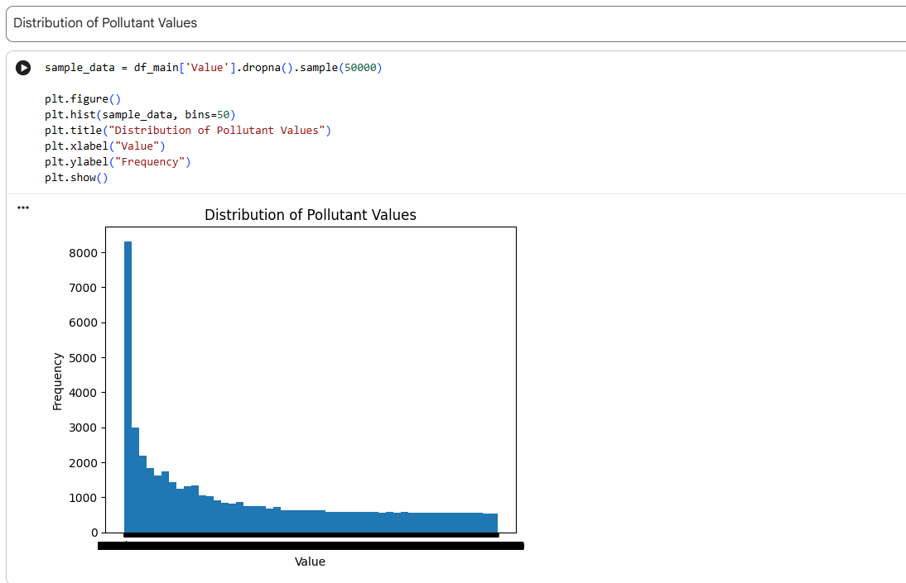
Figure 4: Distribution of Pollutant Concentration Values in the Air Quality Dataset
Interpretation
The values of pollutant concentration are not normally distributed, as indicated by the histogram. Many observations occur at low concentrations; the frequency tapers off as the pollutant increases. This points towards a positive skewness, with most measurements of air quality indicating relatively low concentrations of air pollution, and a smaller proportion pointing to high pollution events. If there are high values in the observations, the data indicate that sometimes the pollution levels are high and could be related to other activities like traffic changes, industrial emissions, or bad weather. It's important to understand this distribution because the performance of machine learning models can be affected by skewed data, and the skewed data may need to be processed later on.

4.2 Pollutant Frequency Analysis
A bar chart was drawn in order to explore the frequencies of the various measurements of pollution in the data. This analysis can be used to determine the percentage of observations made by which pollutant.
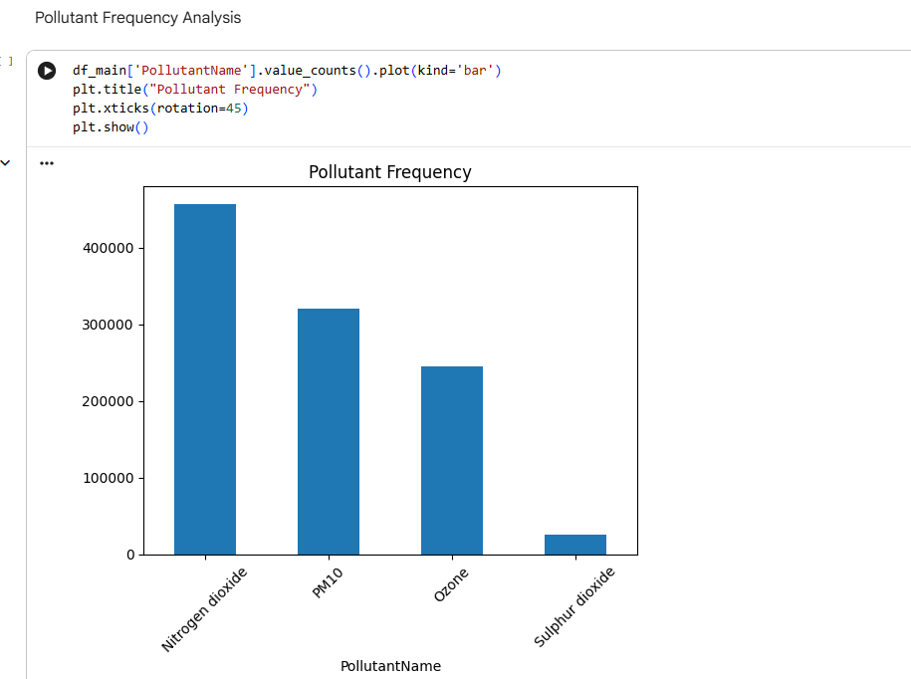
Figure 5: Frequency Distribution of Pollutants in the Air Quality Dataset
Interpretation
The results displayed indicate that the number of observations in the database for Nitrogen Dioxide (NO₂) is highest, followed by PM10 and Ozone measurements. There are fewer observations of sulphur dioxide (SO₂). The high proportion of NO₂ measurements justifies its use as the main target variable for this research. NO₂ is the largest proportion of records available, making it a good basis for statistical analysis and predictive modelling. The difference in observation numbers is also accounted for by differences in the priorities and frequency with which pollutants are monitored from station to station.

4.3 Average Pollution Over Time
The average concentration for each timestamp was estimated to examine the temporal distribution of pollution, and a line chart was used to illustrate this. This analysis gives information on variations in pollution levels over time.
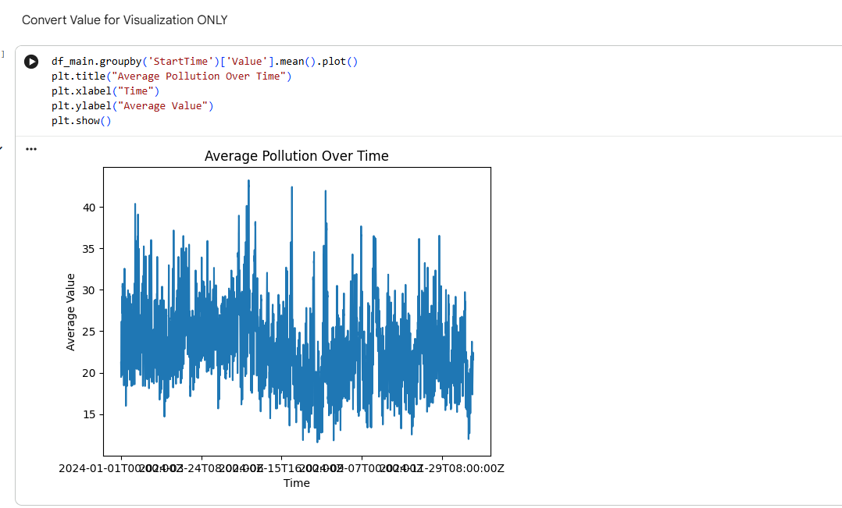
Figure 6: Temporal Trend of Average Pollutant Concentrations
Interpretation
The plot of the time series shows significant fluctuations in average pollution levels over time. Pollution levels are constantly changing, suggesting that air quality is subject to dynamic environmental and anthropogenic factors. There are a number of peaks that can be seen in the average concentrations of pollutants that are much higher than the norm. The peaks may represent times when traffic, industries or meteorological conditions have increased. The same is true for low concentration times, which indicate better air quality. These fluctuations add to the uncertainty of air pollution data as it is time-dependent and emphasise the need to consider temporal data when modelling air pollution.

4.4 Pollutant Distribution Comparison
A boxplot was created to compare the distribution of pollutant concentration between different pollutant categories. This visualisation shows information about central tendency, variability, and outliers.
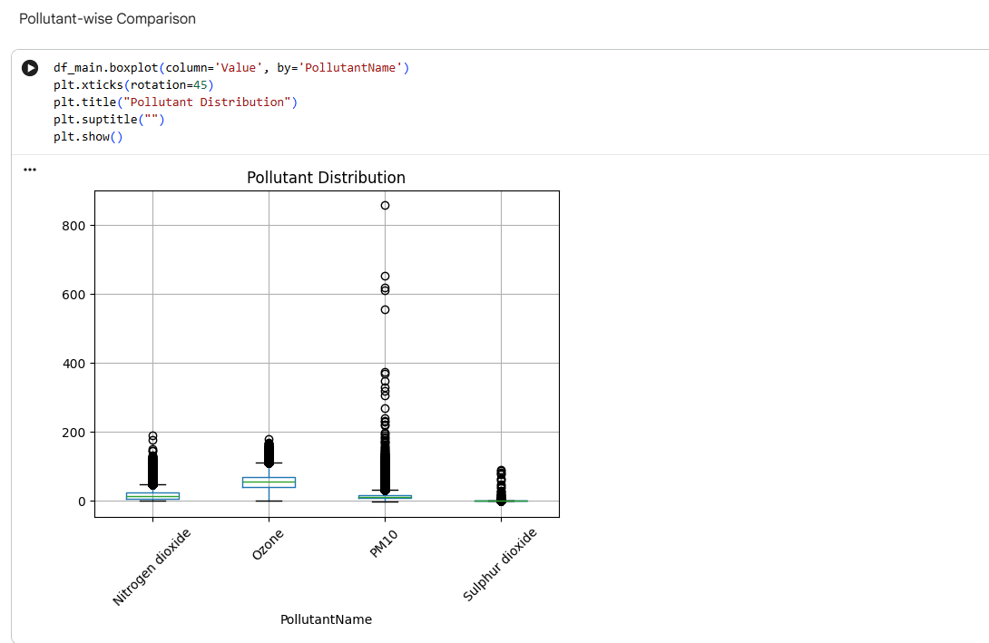
Figure 7: Comparative Distribution of Pollutant Concentrations by Pollutant Type
Interpretation
The box plot shows that the distributions of concentration are significantly different between pollutants. The median values for O₃ are the highest, whereas Sulphur Dioxide shows generally lower concentrations. There is high variability in PM10 and a large number of extreme outliers. Many outliers are present, signifying that pollution events sometimes exceed the normal levels. This is typical in environmental data sets and could be extreme pollution events. The differences in the pollutants highlight the complexity of air quality measurements and thus the requirement for further analysis of these measurements before predictive modelling.

4.5 Top Monitoring Stations Analysis
A bar chart was created to determine the number of observations from each monitoring station in the data set. The knowledge of the activity at the station is useful for assessing data coverage and locating the station's key stations.
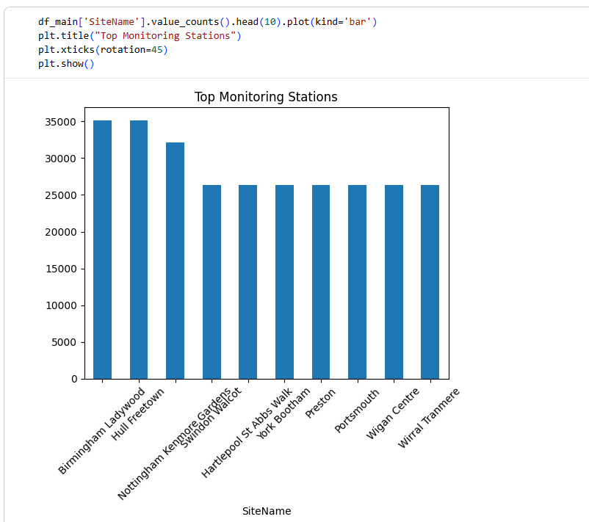
Figure 8: Top Air Quality Monitoring Stations by Number of Recorded Observations
Interpretation
The analysis shows that the number of observations was greatest at stations like Birmingham Ladywood, Hull Freetown and Nottingham Kenmore Gardens. Other stations, such as Hartlepool St Abbs Walk, York Bootham, Wigan Centre, Wirral Tranmere and Portsmouth, also provided significant data. These sites had relatively high observation counts, indicating regular monitoring and a high level of data available. These stations are important for providing the representation of air quality in various urban settings. The distribution of monitoring stations in several regions allows for the enhancement of the representativeness of the monitoring network and thus enables more reliable environmental analysis.

4.6 Summary of EDA Findings
An exploratory analysis proved useful in understanding the data structure and properties of the air quality data. The results indicated that the concentrations of pollutants were skewed and had a number of extreme observations. Nitrogen Dioxide (NO₂) was determined as the most common pollutant measured, and consequently, it was selected as the main target variable in this research. This temporal analysis showed that the pollution levels had been continuously fluctuating with time, thus emphasising the dynamism of the air quality data. The boxplot analysis showed large variations between the pollutant types, and the monitoring station analysis showed a wide geographical spread throughout the United Kingdom. The results obtained thus provide an important basis for the next steps in the project, which include data preprocessing, feature engineering, and the development of machine learning models for forecasting NO₂ concentrations.

